DR. VISHWANATH KARAD MIT WORLD PEACE UNIVERSITY
School of Engineering & Technology
Department of Electrical & Electronics Engineering
Academic Year: 2025–26
CIRCUIT CONCLAVE HACKATHON 2026
BILL OF MATERIALS (BOM)
4×4 Register File with Read/Write/Clear
Harshvardhan Rathod (PRN: —————) & Alok Deep Verma (PRN: —————) | FY B.Tech E&CE | Div: 23 | 2025–26

Source: RAM-project-001.csv — KiCad BOM export. All ICs are standard 74-series TTL in DIP packages from Texas Instruments, sourced from the project custom library (RAM-project-001-library-footprint).

FULL COMPONENT LIST
KiCad Ref | Part / Value | Specification | Qty | Purpose | Cost
A7408 | SN74LS08N | Quad AND Gate, DIP-14 | 1 | Write-enable clock gating
B074244 | SN74LS244N | Octal 3-State Buffer, DIP-20 | 1 | Tri-state read bus (Bus 0)
B174244 | SN74LS244N | Octal 3-State Buffer, DIP-20 | 1 | Tri-state read bus (Bus 1)
CC1 | Capacitor | Ceramic Disc, 0.1 µF 50V | 1 | VCC decoupling
CC2 | Capacitor | Ceramic Disc, 0.1 µF 50V | 1 | VCC decoupling
CNE555 | NE555P | 555 Timer, DIP-8 | 1 | 0.5 Hz astable clock
CR1 | Resistor | 10 kΩ ¼W Axial | 1 | 555 R1 — charge path
CR2 | Resistor | 68 kΩ ¼W Axial | 1 | 555 R2 — timing
D74139 | SN74LS139AN | Dual 2-to-4 Decoder, DIP-16 | 1 | 2-bit address decoding
D074175 | SN74LS175N | Quad D Flip-Flop, DIP-16 | 1 | 4-bit register — Row 0
D174175 | SN74LS175N | Quad D Flip-Flop, DIP-16 | 1 | 4-bit register — Row 1
D274175 | SN74LS175N | Quad D Flip-Flop, DIP-16 | 1 | 4-bit register — Row 2
D374175 | SN74LS175N | Quad D Flip-Flop, DIP-16 | 1 | 4-bit register — Row 3
DIS0–DIS3 | SW_100SP1T1B4M2QE | E-Switch SPST | 4 | Data input D0–D3
AS0, AS1 | SW_100SP1T1B4M2QE | E-Switch SPST | 2 | Address input A0–A1
N7402 | SN7402N | Quad NOR Gate, DIP-14 | 1 | Row-select clock gating
O7432 | SN7432N | Quad OR Gate, DIP-14 | 1 | Asynchronous clear logic
OL0–OL3 | CQY99 | LED 5mm T-1 3/4, LED_D5.0mm | 4 | Output bus bit indicators
OR0–OR3 | Resistor | 220 Ω ¼W Axial | 4 | LED current limiting
SWC1 | SW_100SP1T1B4M2QE | E-Switch momentary | 1 | Clear button (→ LOW)
SWW1 | SW_100SP1T1B4M2QE | E-Switch momentary | 1 | Write/RW button (→ HIGH)

COMPONENT SUMMARY
Category | Qty | KiCad Reference(s) | Cost
ICs (7 unique types) | 11 | A7408, B074244, B174244, CNE555, D74139, D074175–D374175, N7402, O7432
Switches (E-Switch) | 8 | DIS0–DIS3, AS0, AS1, SWC1, SWW1
LEDs | 4 | OL0–OL3
Resistors | 6 | OR0–OR3, CR1, CR2
Capacitors | 2 | CC1, CC2
TOTAL | 31 | —

Total: 31 components | Single +5V supply | PCB: KiCad RAM-project-001

PCB LAYOUT — KiCad RAM-project-001
The PCB layout below shows the placement of all 31 components across the memory, allocator, and clock sections.

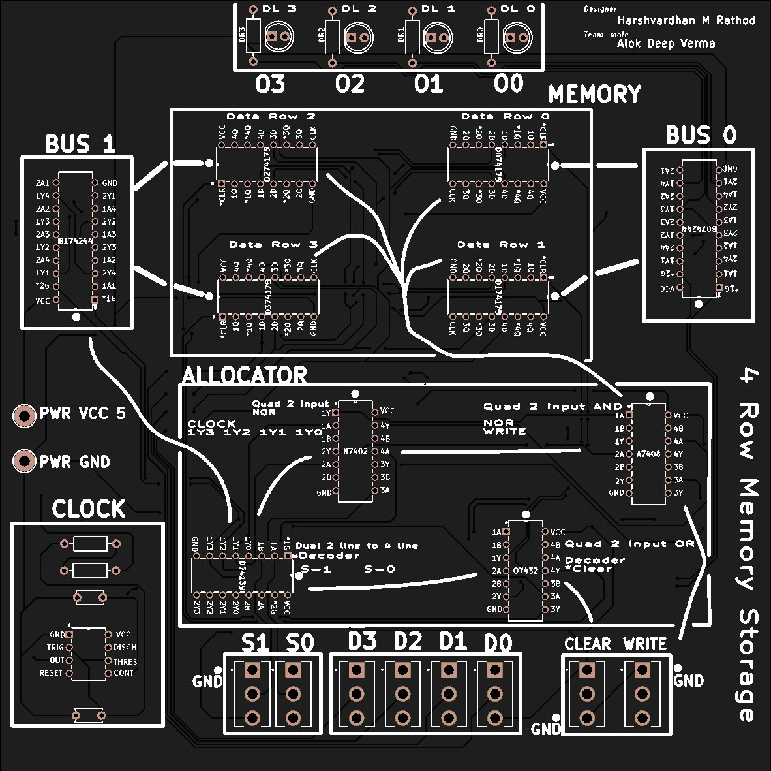
Figure 1: 4 Row Memory Storage — KiCad PCB (RAM-project-001). Designer: Harshvardhan M Rathod | Teammate: Alok Deep Verma
COMPONENT NOTES
1. Integrated Circuits
All ICs are standard 74-series TTL in DIP packages from Texas Instruments. The SN74LS175N (×4) forms the 4-bit register array. The SN74LS139AN decodes the 2-bit address. The SN74LS244N (×2) provides tri-state bus buffering. NOR (SN7402N) and AND (SN74LS08N) gates form the clock-gating logic. OR gates (SN7432N) implement the asynchronous clear network.
2. Switches
All switches use the E-Switch SW_100SP1T1B4M2QE footprint. Data and address inputs use SPST variants (one per bit); Clear and Write use momentary variants. No separate clock button is placed — clock is generated automatically by the NE555P astable circuit at 0.5 Hz.
3. LEDs & Passives
Four CQY99 LEDs (OL0–OL3) with 220 Ω current-limiting resistors display the output bus. The NE555P timing network uses CR1=10 kΩ (R1), CR2=68 kΩ (R2), and a 20 µF electrolytic timing capacitor (add as polarised capacitor CP if not already in schematic). CC1, CC2 are 0.1 µF ceramic disc VCC decoupling capacitors.
4. Cost Column
The Cost column has been left blank as component prices are subject to change. Please refer to current pricing from authorised distributors (e.g., DigiKey, Mouser, Element14) or local suppliers at the time of procurement.

Submission Date: __________________  Verified by (Faculty Mentor):  __________________________ | Faculty Mentor Signature:  __________________________  Team prismlabs Signature:  __________________________

